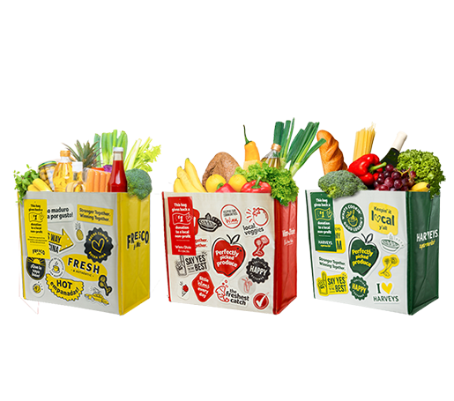

GIVING TAG PROGRAM

Sample Email

DOWNLOAD IMAGES
SUBJECT LINE: Buy a Bag, Redeem the Tag and We’ll Get $1!

PREVIEW TEXT: Look for the Giving Tag on every reusable Community Bag purchased at Winn- Dixie, Fresco y Más or Harveys and direct $1 to us!

Dear [Staff/Board/Volunteers],

We are so excited to announce the Giving Tag Program at Winn-Dixie, Fresco y Más and Harveys, which makes it easy for customers to direct donations to local nonprofit organizations of their choice.

At any Winn-Dixie, Fresco y Más or Harveys location, just purchase a $2.99 reusable Community Bag, follow the instructions on the Giving Tag that comes with it, select [organization] and we’ll receive a $1 donation!

Let’s get started! Share the news with friends and family. Call, send emails and post on social media. The more people who purchase the Community Bag and use the Giving Tag to direct the donation to [organization], the more we can raise!
To learn more about this program, please visit seg.2givelocal.com.
Best,
[Signature]

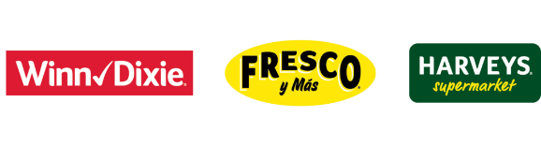
seg.2givelocal.com

