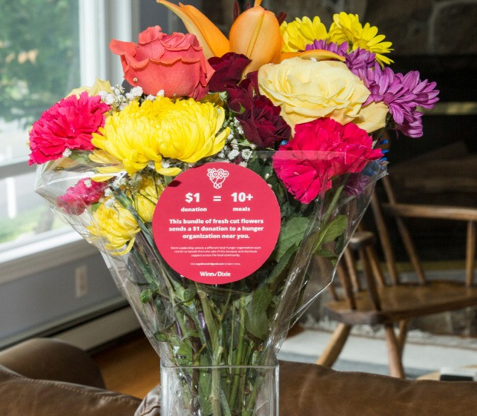

BLOOMIN’ 4 GOOD PROGRAM
Sample Press Release

DOWNLOAD IMAGES

FOR IMMEDIATE RELEASE: [Name of organization] [Name, phone & email]

[Name of organization] Celebrates Selection as a Winn-Dixie Bloomin’ 4 Good Program Beneficiary

[City, State] – [Name of organization] has been selected as a beneficiary of the Winn-Dixie Bloomin’ 4 Good Program for the month of [month].

The Winn-Dixie Bloomin’ 4 Good Program, which launched in October 2021, is an easy way for shoppers to give back. Every $12.99 Bloomin’ 4 Good Bouquet with the red circle sticker sold supports a hunger organization local to the Winn-Dixie in which it was purchased.

[Name of organization] was selected as the [month] beneficiary by local store leadership at the Winn-Dixie located at [location]. [Name of organization] will receive a $1 donation for every $12.99 Bloomin’ 4 Good Bouquet purchased at this Winn-Dixie location in [month].

“Flowers can make someone’s day, brighten a room or spread a smile,” said [name], Executive Director of [name of organization]. “Now they can fight hunger too. Purchase a Bloomin’ 4 Good Bouquet at [town] Winn-Dixie in [month] to help fight hunger. Every bouquet sold will feed 10+ people in need.”

[Name of organization] is a nonprofit based in [city, state]. Founded in [year], [name of organization] has [describe efforts in the community]. Learn more about [name of organization] by visiting [website].

For more information about the Winn-Dixie Bloomin’ 4 Good Program, please visit seg.2givelocal.com.

seg.2givelocal.com

