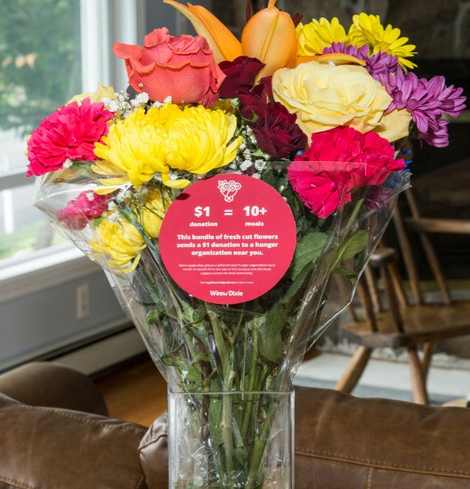

BLOOMIN’ 4 GOOD PROGRAM
Sample Email

DOWNLOAD IMAGES

SUBJECT LINE: Buy a Bouquet and We’ll Get $1 from Winn-Dixie!

PREVIEW TEXT: For all of [Month] every Bloomin’ 4 Good bouquet purchased at Winn-Dixie earns us $1!

Dear [Staff/Board/Volunteers],

We are so excited to share that [organization] has been selected to benefit from Winn-Dixie’s Bloomin’ 4 Good Program, created to fight hunger across the communities it serves.

For the month of [month], a $12.99 Bloomin’ 4 Good Bouquet with the red circle sticker from the Winn-Dixie at [location] will brighten a home or make someone’s day while also directing a $1 donation to [organization].

This is a great way to broaden awareness in the local community and raise donations for our organization to help fight hunger.

Let’s get started! Share the news with friends and family. Call, send emails and post on social media. The more bouquets sold, the more we can raise!
To learn more about this program, please visit seg.2givelocal.com.
Best,
[Signature]

seg.2givelocal.com

