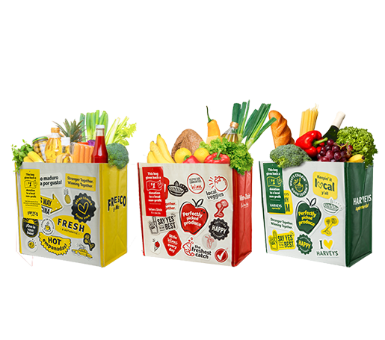

GIVING TAG PROGRAM

Sample Press Release

DOWNLOAD IMAGES

FOR IMMEDIATE RELEASE: [Name of organization] [Name, phone & email]

[Name of your organization] Participating in Giving Tag Program

[City, State] – [Name of your organization], a nonprofit committed to [description of organization], has begun generating donations through the Giving Tag Program at Winn-Dixie, Fresco y Más and Harveys.

The Giving Tag Program, which launched in February 2019, is a reusable bag program that facilitates community support with the goal to make a difference in the communities where shoppers live and work.

When a shopper purchases the $2.99 reusable Community Bag at any Winn-Dixie, Fresco y Más
or Harveys store, they have the opportunity to direct a $1 donation to a local nonprofit by using the attached Giving Tag. [Name of organization] has already begun generating donations through the use of the Giving Tag.

“[1-2 sentence quote reflecting excitement about participating in the program],” said [name of your organization] Executive Director, [name]. “[Short quote on how this donation will help you fulfill your mission].”

[Name of organization] is a nonprofit based in [city, state]. Founded in [year], [name of organization] has [describe efforts in the community since founding of company]. Learn more about [name of your organization] by visiting [website].

For more information on the Giving Tag Program, visit seg.2givelocal.com.

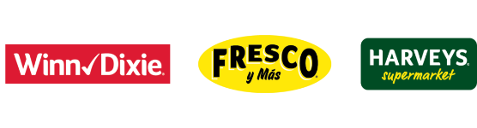
seg.2givelocal.com

