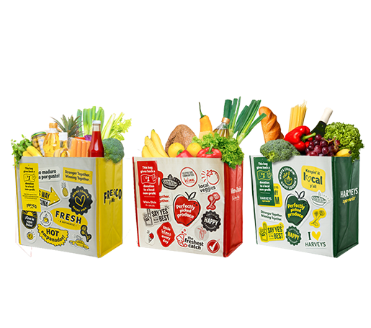

GIVING TAG PROGRAM

Thank Your Supporters Email & Social Post

DOWNLOAD IMAGES
SUBJECT: Thank you for your support!

Hello,

Thank you for purchasing a Community Bag from Winn-Dixie, Fresco y Más or Harveys and using its attached Giving Tag to direct the $1 donation to [name of your organization]. We’ve raised a total of $[donation amount] so far!

Whether you’ve bought a bag or helped spread the word, we couldn’t have done this without you. The money generated through this program will help us to [share what you will do with the funds raised].

If you haven’t had a chance to pick up a bag yet, don’t worry! The Giving Tag Program runs all year long.
All you have to do is purchase the Community Bag at any Winn-Dixie, Fresco y Más or Harveys store
and follow the instructions on the attached Giving Tag to direct the $1 donation to our organization.

To learn more about this program, please visit seg.2givelocal.com. Thank you for your continued support!

Share With Your Followers
Thank you! We raised $[donation amount] through the
Giving Tag Program! Guess what? You can
continue to support us by visiting any Winn-Dixie, Fresco y
Más or Harveys, purchasing the Community Bag and
using the attached Giving Tag to send a $1 donation
to us any time throughout the year.

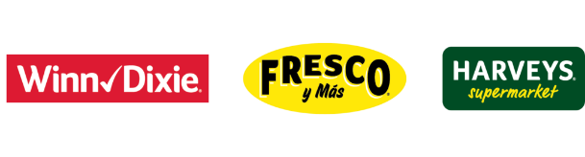
seg.2givelocal.com

