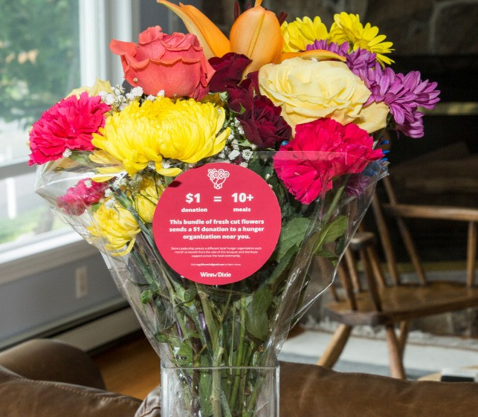

BLOOMIN’ 4 GOOD PROGRAM
Sample Press Release

CLICK HERE FOR MARKETING MATERIALS

FOR IMMEDIATE RELEASE: [Name of organization] [Name, phone & email]

[Name of organization] has been selected as March’s Winn-Dixie Bloomin’ 4 Good Program beneficiary.

[City, State] – For the entire month of March, [Name of organization] will receive $1 donation from every $12.99 Bloomin’ 4 Good bouquet with the red circle sticker sold at Winn-Dixie’s [location] location.

The Winn-Dixie Bloomin’ 4 Good Program is an easy way for shoppers to give back to their communities. Every month, leadership at each Winn-Dixie store selects a hunger organization to benefit from the sales of Bloomin’ 4 Good bouquets. Since the Program launched in October 2021, over $150,000 has been donated to more than 1,000 hunger organizations.

“Brighten someone’s day while giving back locally!” said [name], Executive Director of [name of organization]. “Purchasing a Bloomin’ 4 Good Bouquet at [town’s] Winn-Dixie in March will help our organization serve our community better.”

[Name of organization] is a nonprofit based in [city, state]. Founded in [year], [name of organization] has [describe efforts in the community]. Learn more about [name of organization] by visiting [website].

For more information about the Winn-Dixie Bloomin’ 4 Good Program, please visit seg.2givelocal.com.

seg.2givelocal.com

