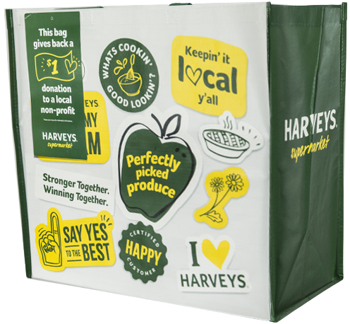
COMMUNITY BAG PROGRAM

Announcement Email

SUBJECT LINE: We’ve been selected by the Harveys Community Bag Program!

PREVIEW TEXT: For all of [Month], we will receive $1 for every reusable Community Bag purchased at Harveys!

Dear [Staff/Board/Volunteers/Supporters],

We are so excited to share that [organization] has been selected to benefit from the Harveys Community Bag Program, which makes it easy for shoppers to contribute to their local communities.

For the month of [month], whenever a $2.99 reusable Community Bag is purchased at the Harveys located at [location], $1 will be donated to [organization]. This is a great way to broaden awareness and help our cause.

The Harveys Community Bag Program, which launched in February 2019, is a reusable bag program that facilitates community support with the goal of making a difference in the communities where shoppers live and work. Since inception, the Program has donated more than $500,000 to almost 8,900 nonprofit organizations.

Let’s get started! Share the news with friends and family. Call, send emails, and post on social media. The more people who purchase the Community Bag in [month], the greater the donation we will receive!
To learn more about this program, please visit seg.2givelocal.com.
Best,

[Signature]

